HUNTINGTOWN VOLUNTEER FIRE DEPARTMENT& RESCUE SQUAD, INC.

29thAnnual

“CLASSIC CORVETTE CONTEST”
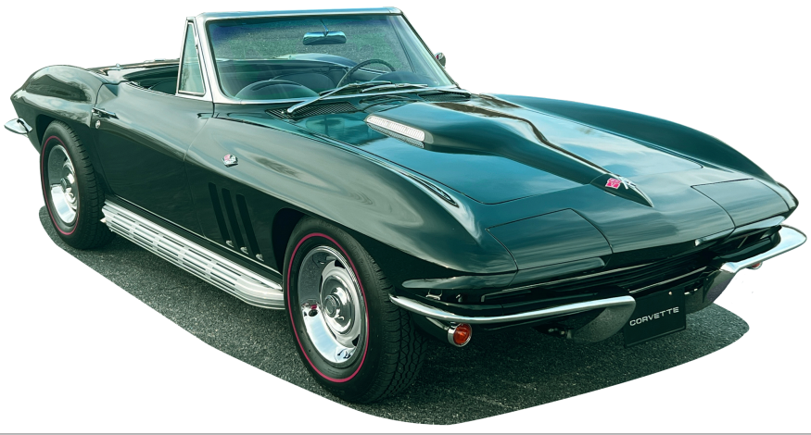
You could be the winner of this 1965 Corvette Convertible
Glen Green • 327 Cubic inches with 300 horsepower
4 Speed Manual Trans • New Side Pipes
Leather Interior • Red Line Tires • Matching Numbers
1ST PRIZE: 1965 Corvette Convertible or $25,000.00
2nd Prize: $2000.00 – 3rd Prize: $1000.00 – 4th Prize: $700.00 – 5th Prize: $300.00.

Drawing: October 20, 2024
Winner need not be present to win!
$10.00 per sheet of 15 tickets. One name per sheet of tickets.
U.S. Funds only.

- - - - - - - - - - - - - - - - - - - - - - - - - - - Mail In Order Form - - - - - - - - -- - - - - - - - - - - - - - - -

Name:____________________________________________________________________

Address:__________________________________________________________________

City:____________________________________ State: __________ Zip: ______________

Phone #: ____________________ Email:_______________________________________

# of Sheet(s) ________ x $10.00 (U.S. Funds only)

Make payable to: Huntingtown VFD
Mail To: Huntingtown Volunteer Fire Dept.
P.O. Box 987
Huntingtown, MD. 20639

Ticket request must be received before October 12, 2024. Tickets will be mailed prior to drawing. Winner responsible for state and federal taxes, fees, and delivery. Winner is responsible for providing valid form of identification to receive prize. Void where prohibited.
Winners have 30 days to claim prize or forfeit winnings. Rules posted on our website. Good Luck, Thank You.
For more information email us at Corvette@hvfd6.org or visit our Information Line at 410-414-3427.
www.hvfd6.org

